EXERCISE 2.1

**NCERT Solutions for Class 10 Chapter 1-**

**Real Numbers**

EXAMBUDDY

Question 1:

The graphs of y = p(x) are given in Fig. 2.10 below, for some polynomials p(x). Find the number of zeroes of p(x), in each case.

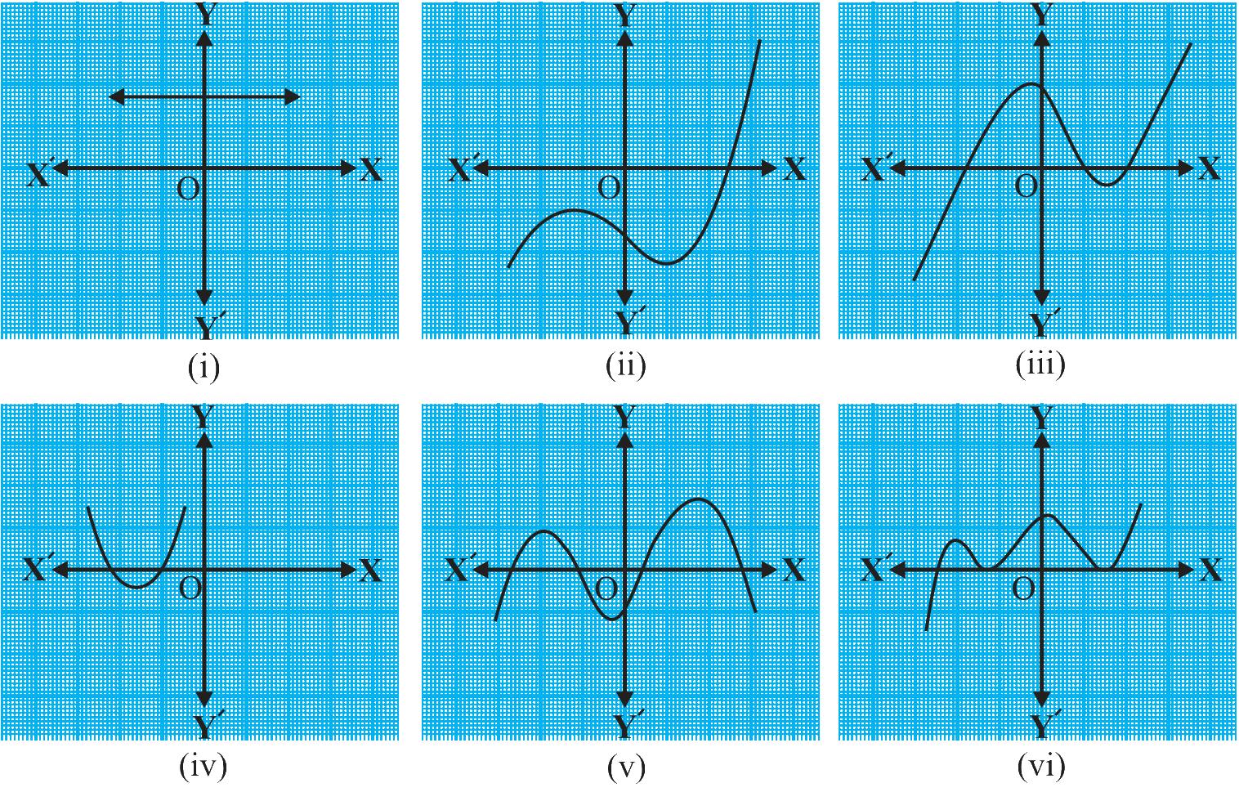  
Solution:

(i) The number of zeroes is 0 as the graph doesn’t cut the x-axis at any point.

(ii) The number of zeroes is 1 as the graph cuts the x-axis at only one point.

(iii) The number of zeroes is 3 as the graph cuts the x-axis at 3 points.

(iv) The number of zeroes is 2 as the graph cuts the x-axis at 2 points.

(v) The number of zeroes is 4 as the graph cuts the x-axis at 4 points.

(vi) The number of zeroes is 3 as the graph cuts the x-axis at 3 points.

**NCERT Solutions for Class 10 Chapter 2-**

**Polynomials**

EXAMBUDDY